Business Requirements Document

[BRD]

**Mass Notification System(MNS)**

Deerwalk Institute of Technology

Version 1.0

*Sagar Giri*

Contents

Version and Approvals 1

Glossary of Terms 1

Project Details 2

Executive Summary 2

Document Resources 2

Vision and Scope 3

4.1 Project Overview and Background 3

4.2Scope of Initial Release and Future Releases 3

4.2.1 Limitations and Exclusions 4

4.3 Project Dependencies 4

4.4 Stakeholders and their Profiles 4

4.5 Project Timeline 5

Key Assumptions and Constraints 5

5.1 User Load 5

5.2 Key Assumptions and Constraints 5

5.3 Major Features 7

Use Cases 7

Use Case Narrative 7

Business Requirements 10

Business Process Flows 10

Business Rules Catalog 10

# Version and Approvals

|  |  |  |  |
| --- | --- | --- | --- |
| **Version History** |  |  |  |
| **Version #** | **Date** | **Revised By** | **Reason for Change** |
| **1.0** |  |  | **Sagar Giri “First Version”** |
|  |  |  |  |
|  |  |  |  |
|  |  |  |  |

This document has been approved as the official Business Requirements Document for Mass Notification System mentioned as MNS hereafter, and accurately reflects the current understanding of business requirements. After approval of this document, requirement changes will be governed by the project’s change management process, including impact analysis, appropriate reviews and approvals.

|  |  |  |  |
| --- | --- | --- | --- |
| **Document Approvals** |  |  |  |
| **Approver Name** | **Project Role** | **Signature/Electronic Approval** | **Date** |
| **Hitesh Karki** | **Director of Academic Affair - DWIT** |  |  |

# Glossary of Terms

| **Term/Acronym** | **Definition** |
| --- | --- |
| MNS | Mass Notification System |
| DWIT | Deerwalk Institute Of Technology |
| TBD | To Be Determined |

# Project Details

|  |  |
| --- | --- |
| **Project Name** | Mass Notification System - MNS |
| **Project Type** | **NEW INITIATTIVE** |
| **Project Start Date** | 05/20/2014 |
| **Project End Date** | TBD |
| **Project Sponsor** | Deerwalk Institute of Technology |

# Executive Summary

It is often observed in DWIT that students aren't able to keep track of college time according to the college schedule. Students arriving late in class and college meetings or events causes disruption to many students as well as the teachers. The main cause of this problem is that the students aren't notified in time when such college programs are being conducted. The class representatives (CR) has to inform each and every students who are outside the class by calling to their cell phones.

The Mass Notification System (MNS) helps to fix this problem. MNS assists to invite the student in the event venue or lecture class in time. The class representatives won't have to call each and every students who are outside the class to be in the college event or when the teacher arrives in the class. MNS helps to inform/alert students to be in the class or venue of the college event in simple way. Overall, MNS will help in informing students about the college event such as meetings, talk programs or club activity including the venue and time or the lecture classes so that students won't miss any of the lectures or attending a college event as well as teachers waiting time for late comers will be saved.

# Document Resources

| **Name** | **Business Unit** | **Role** |
| --- | --- | --- |
| Students | Students of DWIT | The end user who can receive notification form class representative about college event or any teacher's lecture class. |
| Authorized User | Class representatives, Club presidents, Faculty members or the Event organizer | The authorized user has a permission to inform other students about the lecture class or the event schedule and venue. |
| Administration | Key member of the college administration | The administrative officer who manages user credentials and does the user management. |

# Vision and Scope

## 4.1 Project Overview and Background

**Background**

When teacher arrives late in the class, the class representative has to call every students who are outside the class to attend the lecture. In addition to that, if an event has to be conducted immediately, the class representatives has to inform every students by calling to their cell phone (which costs money) or to inform them via email (in this case the students might not see the email in that time). Hence, when students arrive late in the class or a college event, it causes disruption to many students as well as the teachers.

**Business Opportunity**

College meetings are held more often in DWIT. Every student must attend to those events because it is mandatory. Student who are not able to attend the event are punished unless they provide a valid reason. Similarly students are not allowed to enter into the classroom if he/she is late for more than 5 minutes. To inform every students about the event or lecture classes, the class representative (CR) have to inform them by calling to their cell phones or by sending an email. Therefore, this is a great deal of opportunity to sell this product in order to minimize the time and cost to inform all the students about the college events or lectures.

Students as well as faculty members will be immediately benefit from this product because students wont be missing any teacher's class or the college events. Students will be able to keep track of time as per the college schedule and the chances of missing the lectures or the college event will be minimized. And there won't be any disruption in the event by the late comers. Beyond the immediate benefit to students of DWIT, this application has a business opportunity for students of other colleges of Nepal who are struggling to keep track of time according to their college schedule.

**Customer Needs**

There is a great need of this application. Student needs a centralized service to keep track of class time as well as events time and venue. This alert system will assist students to arrive in class or in any college event in time. This application will save a lot of money as well as time of the student and teacher.

## Scope of Initial Release and Future Releases

|  |  |  |
| --- | --- | --- |
| **Feature** | **Initial Release** | **Future Releases** |
| Configure the system | Administrator | Administrator |
| User Management | Administrator |  |
| Login/Logout | Administrator/ Authorized user/ Student |  |
| Use the system to inform about events to other student | Authorized user | Authorized user |
| Get notification | Students / Authorized user | Students/ Authorized user |

### 4.2.1 Limitations and Exclusions

|  |  |
| --- | --- |
| Limitations | Exclusions |
| Only authorized user can use this application to invite or alert the students of DWIT | Only Android Version available in this initial release |
| Only operate only inside the DWIT premises in this initial release |  |
| Users have to update the application once the administrator changes something in the system |  |

## 4.3 Project Dependencies

* This project cannot proceed without an APPROVAL from the mentor to carry on with the project is mandatory.
* The MNS should be able to make use of the standard schema so that it can be made easily pluggable.
* User accounts must use the Google Apps Authentication service which is the DWIT standard. (Email address and Google Apps Password)

## 4.4 Stakeholders and their Profiles

The following comprises the internal and external stakeholders whose requirements are represented by this document:

|  | Stakeholder | Major Value | Major Interests |
| --- | --- | --- | --- |
| 1. | Students | Get notification of the college events venue, time and class time. | Saves their time to arrive in the event as well as class so that others wont be disturbed and also to avoid punishments for not attending the college events. |
| 2. | Authorized Users | Informs students and faculty members about the class or any of the college event. | Saves a lot of time, money and effort of informing the students of DWIT and the faculty members via their cell phone or email. |

## 4.5 Project Timeline

|  | **Phase** | **Timeline** |
| --- | --- | --- |
| 1. | Write the Software Requirements Specification | TBD |
| 2. | Develop initial phase | TBD |
| 3. | Write BRD and SRS for future releases | TBD |

# Key Assumptions and Constraints

## 5.1 User Load

I anticipate that all the students of DWIT and faculty will login to the application. The maximum number of student users is 92, 24 Faculty and 1 system administration totaling 117 total users.

## 5.2 Key Assumptions and Constraints

|  |  |
| --- | --- |
| **#** | **Assumptions** |
| 1 | All the users will have access to this system in the college hour. |
| 2 | All the stakeholders will be comfortable using this online Andriod application. |
| 3 | All students and faculty members will be able to use it. |
| 4 | Class representatives will alert the mass 10 minutes before any college event. |
| 5 | Student should be connected to the college Wi-Fi to use this application. |
|  |  |
| **#** | **Constraints** |
| 1 | This is not a fully dependable system that provides end to end solution as validity of college events and class events solely depends on class representatives. |
| 2 | Since its mobile based application, one cannot expect to work perfectly in all available Android versions. |
| 3 | This application will need to operate with other colleges systems. However, we are not yet proposing an integration effort other than Google Apps Authentication Service. Future releases will involve this integration. |

## 5.3 Major Features

|  |  |  |
| --- | --- | --- |
| **Feature Code** | **Use Case ID** | **Feature description** |
| FC – 1 | UC – 1 | USER CONFIGURATION |
| FC – 2 | UC – 2 | RECEIVE THE INVITATION/ALERT MESSAGE ABOUT THE CLASS OR COLLEGE EVENT |
| FC – 3 | UC – 3 | SEND INVITATION/ALERT MESSAGE TO THE STUDENTS AND TEACHERS ABOUT CLASSES OR COLLEGE EVENTS |

# Use Cases

## Use Case Narrative

|  |  |  |  |
| --- | --- | --- | --- |
| Use Case ID: | UC -1 | | |
| Use Case Name: | USER CONFIGURATION | | |
| Created By: | Sagar Giri | Last Updated By: | Sagar Giri |
| Date Created: | 06/25/2014 | Date Last Updated: | 06/25/2014 |

|  |  |
| --- | --- |
| Actors: | ADMINISTRATOR |
| Description: | CREATE USER CREDENTAILS TO LOGIN TO THE SYSTEM |
| Preconditions: | Connected to the Internet with lunched MNS application |
| Postconditions: | Admin logins to the MNS application |
| Normal Course:  ADMINISTRATOR | 1. Sees a welcome message 2. Login to the application 3. Create login credential of all the users 4. Set authority and permission of normal users and authorized users 5. Delete a user 6. Logout of the system |
| Alternative Courses: | Sees an error message based on username/password mismatch or non-existence of the user. |
| Exceptions: | NONE |
| Includes: |  |
| Priority: | HIGH |
| Frequency of Use: | Once per visit |
| Business Rules: | *BusinessRule-1* |
| Special Requirements: | * 24/7 access * Supported by majority of android OS variety |
| Assumptions: | Supported by the latest android versions |
| Notes and Issues: |  |
| Use Case Graphics |  |

|  |  |  |  |
| --- | --- | --- | --- |
| Use Case ID: | UC - 2 | | |
| Use Case Name: | RECEIVE THE INVITATION/ALERT MESSAGE ABOUT THE CLASS OR COLLEGE EVENT | | |
| Created By: | Sagar Giri | Last Updated By: | Sagar Giri |
| Date Created: | 06/25/2014 | Date Last Updated: | 06/25/2014 |

|  |  |
| --- | --- |
| Actors: | STUDENT |
| Description: | This use case describes the way that students get notification from the class representative about the college events with venue or lecture time. |
| Preconditions: | Connected to the Internet with lunched MNS application |
| Postconditions: | User logins to the MNS application |
| Normal Course:  NORMAL USER | 1. Receives welcome message 2. Login to the system. 3. View alert message or notification. 4. Logout of the system. |
| Alternative Courses: | Sees an error message based on username/password mismatch or non-existence of the user. |
| Exceptions: | None |
| Includes: |  |
| Priority: | HIGH |
| Frequency of Use: | HIGH |
| Business Rules | *BusinessRule-2* |
| Spe  cial Requirements: | * 24/7 access * Supported by majority of android OS variety |
| Assumptions: | Supported by the latest android versions |
| Notes and Issues: | Function to change the default password in first login is not available in this use case of first version. |
| Use Case Graphic |  |

|  |  |  |  |
| --- | --- | --- | --- |
| Use Case ID: | UC - 3 | | |
| Use Case Name: | SEND INVITATION/ALERT MESSAGE TO THE STUDENTS AND TEACHERS ABOUT CLASSES OR COLLEGE EVENTS | | |
| Created By: | Sagar Giri | Last Updated By: | Sagar Giri |
| Date Created: | 06/25/2014 | Date Last Updated: | 06/25/2014 |

|  |  |
| --- | --- |
| Actors: | AUTHORIZED USER |
| Description: | This use case describes the way that authorized student sends notification to all the students. |
| Preconditions: | Connected to the Internet with lunched MNS application |
| Postconditions: | User logins to the MNS application |
| Normal Course:  AUTHORIZED USER | 1. Receives welcome message 2. Login to the system 3. View alert message or notification 4. Select student and teacher user ID to send notification 5. Select the venue of program 6. Write short message about the importance of the program if necessary 7. Send the message to selected students and faculty members 8. Logout |
| Alternative Courses: | Sees an error message based on password mismatch, non-existence of the user or authentication of valid user. |
| Exceptions: | None |
| Priority: | HIGH |
| Includes: | UC-2 |
| Frequency of Use: | Once per visit. |
| Business Rules | *BusinessRule-3* |
| Special Requirements: | * 24/7 access * Supported by majority of android OS variety |
| Assumptions: | Supported by the latest android versions |
| Notes and Issues: | Function to change the default password in first login is not available in this use case of first version. |
| Use Case Graphic |  |

# Business Requirements

## Business Process Flows

**Fig: Business processes flow: Mass Notification System(MNS)**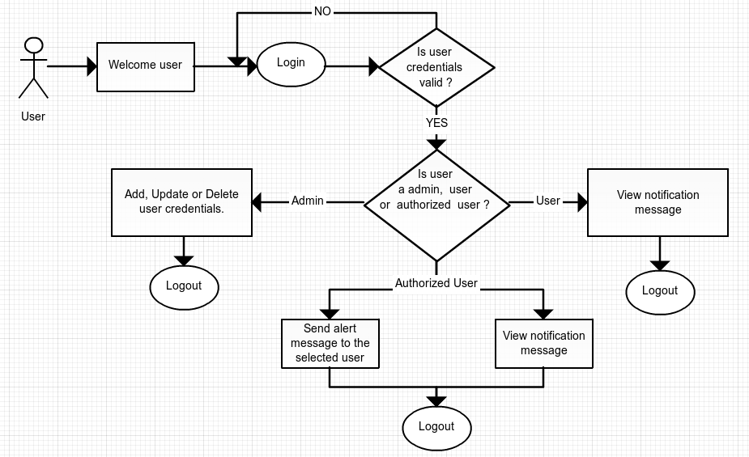

## Business Rules Catalog

|  |  |
| --- | --- |
| Business Rule Name: | Configure User Credential |
| Identifier | *BusinessRule-1* |
| Description | Create user credential with default password for all students and the faculty members. Select authorized user and give special privilege to send the message. |
| Related Rules | None |

|  |  |
| --- | --- |
| Business Rule Name: | Send notification message to students |
| Identifier | *BusinessRule-2* |
| Description | Select user ID (which are hard coded in the application by the administrator) of different users. Select the event venue & time or lecture time. Write message if necessary. Send the message to the selected users. |
| Related Rules | *BusinessRule-3* |

|  |  |
| --- | --- |
| Business Rule Name: | Receive an alert about the event or lectures |
| Identifier | *BusinessRule-3* |
| Description | Cell phone automatically beeps and vibrates when new alert message is received. Student will be able to view about the event details and lecture time before 10 minutes. Can read the message about how important the event is. |
| Example | ***Event:*** *Talk program by Hitesh Karki*  ***Venue:*** *Big seminaar hall*  ***Time:*** *1:00 PM sharp*  ***Message:*** *“Students from all batch are requested to be in this event”* |
| Related Rules | None |